**Medieval Playground**

Made by:

Brinzea Alexandru, 233

Gidea Andrei, 233

Manea Andrei, 233

Panait Andreea, 233

1. **Product Description**

**Medieval Playground** is a two-player cooperative arcade game, where the two main characters are **Dragon** and **Knight**. Players have to work together and use each character's skills to beat the puzzles and finish the levels successfully.

The controls are simple: Dragon is controlled by the arrows, while Knight is controlled by WASD. Each character can touch the spikes matching their own colour, whereas the green spikes are fatal for the both of them. The goal is to reach the door corresponding to their colours.

**Key:**

|  |  |  |
| --- | --- | --- |
|  | **Dragon** | **Knight** |
| **Appearance** | C:\Users\Andreea\Desktop\2019-05-30 16_51_53-Window.png | C:\Users\Andreea\Desktop\2019-05-30 16_52_00-Window.png |
| **Harmless spikes** | **C:\Users\Andreea\Desktop\2019-05-30 17_01_09-Window.png** | **C:\Users\Andreea\Desktop\2019-05-30 17_01_02-Window.png** |
| **Fatal spikes** | **C:\Users\Andreea\Desktop\2019-05-30 17_01_17-Window.png**  **C:\Users\Andreea\Desktop\2019-05-30 17_01_02-Window.png** | **C:\Users\Andreea\Desktop\2019-05-30 17_01_17-Window.png**  **C:\Users\Andreea\Desktop\2019-05-30 17_01_09-Window.png** |
| **Door** | **C:\Users\Andreea\Desktop\2019-05-30 17_01_25-Window.png** | **C:\Users\Andreea\Desktop\2019-05-30 17_01_31-Window.png** |
| **Props they can interact with** | **C:\Users\Andreea\Desktop\2019-05-30 17_01_38-Window.png** | |

1. **Level 1**

**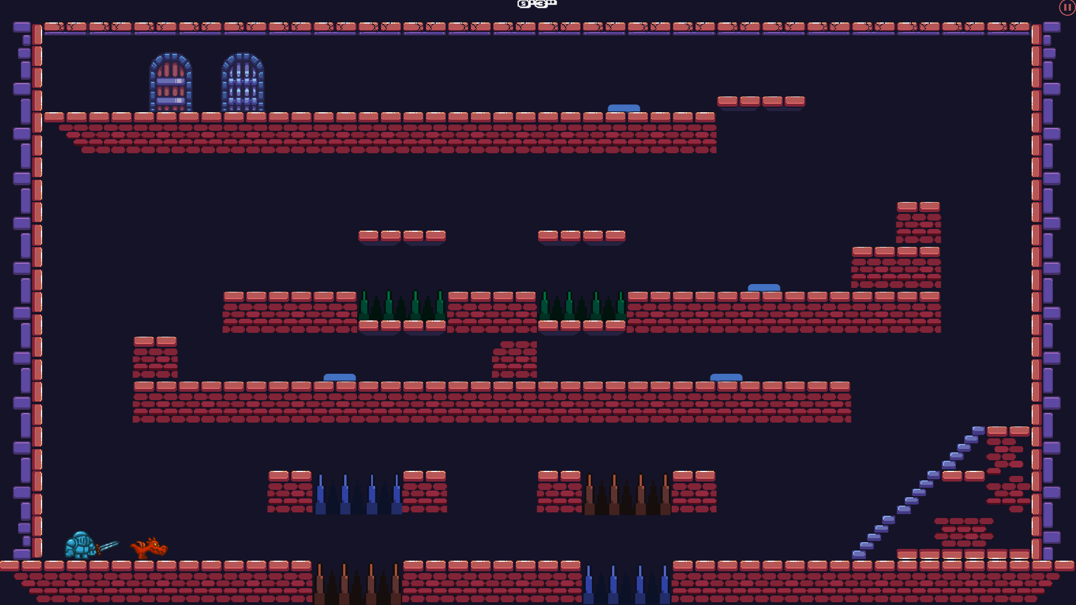**

Dragon must walk through the red spikes and Knight through the blue ones until they reach the 2nd floor. Once there, they must work as a team, with one of them pressing the button while the other one passes under the moving brick tile; afterwards they switch roles. On the 3rd floor, the characters have to jump over the green spikes. When they reach the button, the solution is identical to the one surrounding the first two buttons. Finally, they reach the doors leading to the next level.

1. **Level 2**

**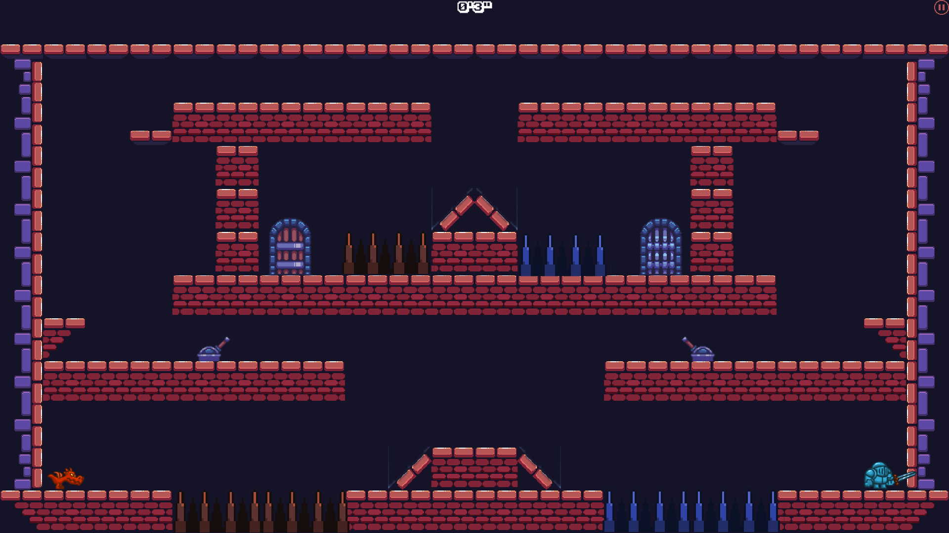**

Both Dragon and Knight have to get on the platform from the middle. From there, they’ll have to jump on the 2nd floor. They will each find a lever that makes another brick platform appear, that will help the characters to get on the room where their doors are located.

1. **Level 3**

**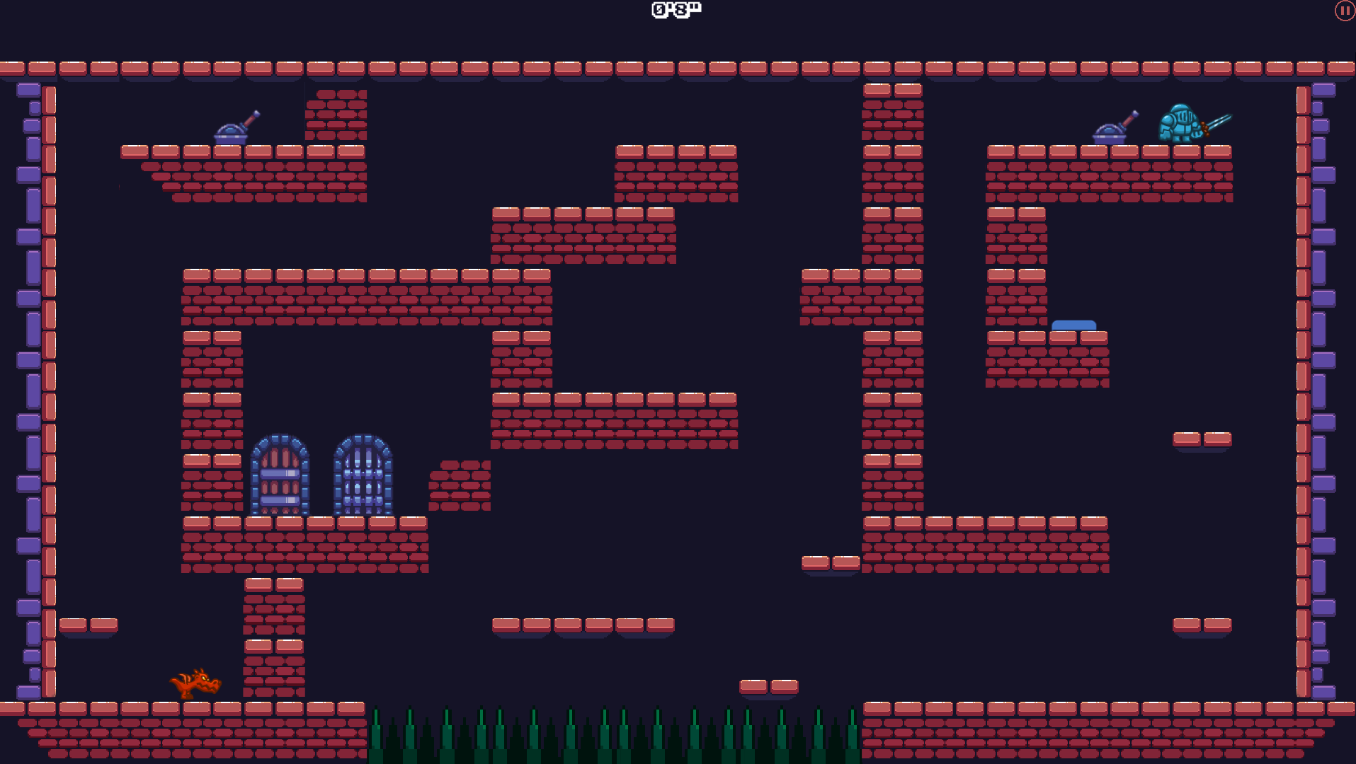**

Dragon has to jump on the platform next to him which will then move upwards after Knight uses the lever. The button near Knight will activate the brick tile blocking the entrance to the lever in upper left corner which will become accessible to Dragon. The aforementioned lever will trigger the brick tile obstructing the doors. Both characters will then have to avoid the green spikes in order to reach their own doors.

1. **Level 4**

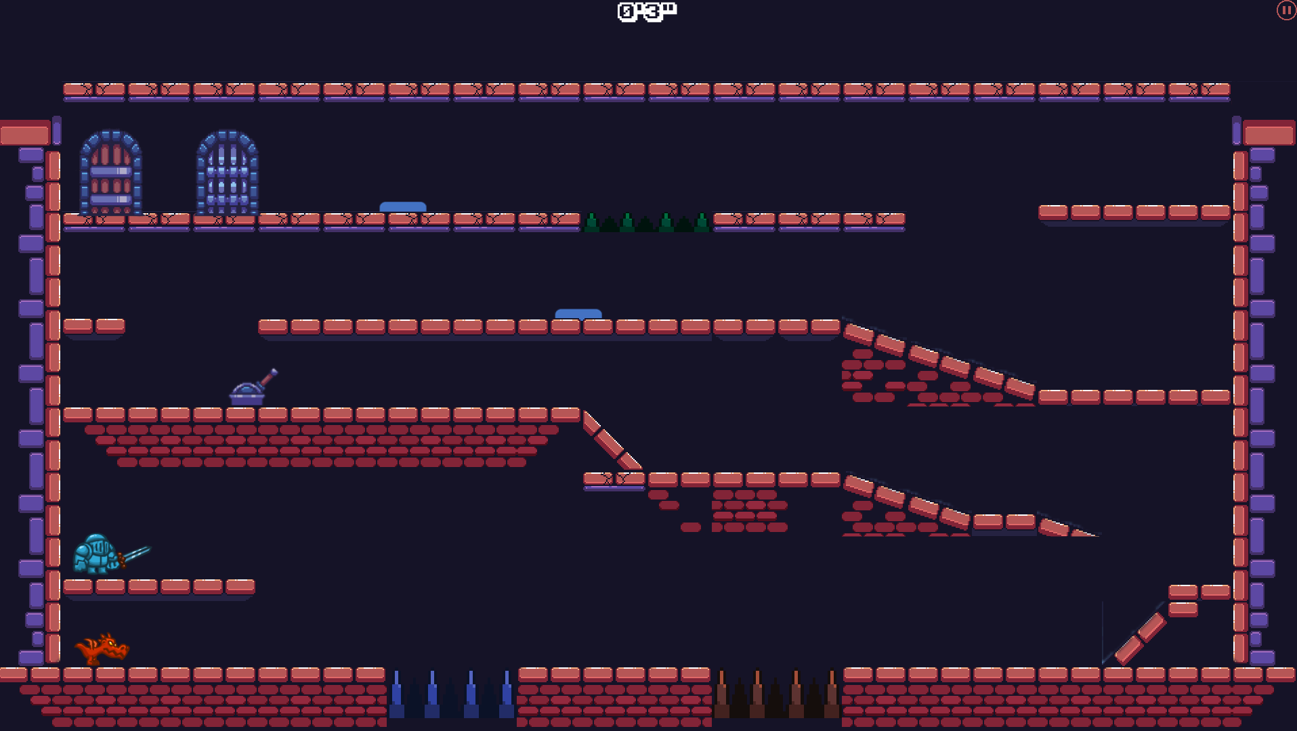

Because this is the last level, we made the jumping height of each character lower, in order to deliver a more challenging experience. Both Dragon and Knight start from the same point approximately, and each of them has to avoid their fatal spikes in order to get to the second floor. There they will encounter a lever that will lower a brick tile, so they could jump onto the next floor. On the 3rd floor we will find a button that will lower another brick tile that will help one character reach the final floor, where another button is located. The character that is now on the final floor will have to press to button in order to help his friend get on the final floor too. On the 4th floor, they have to avoid the green spikes, and then arrive at their designated doors.